Work report 12 july 2021

Downloaded 500 images from the class person from coco dataset.

Code link-

<https://github.com/anshulutk123/COCO_dataset_custom_classes_Downlaod/blob/main/data_collection_coco_dataset.ipynb>

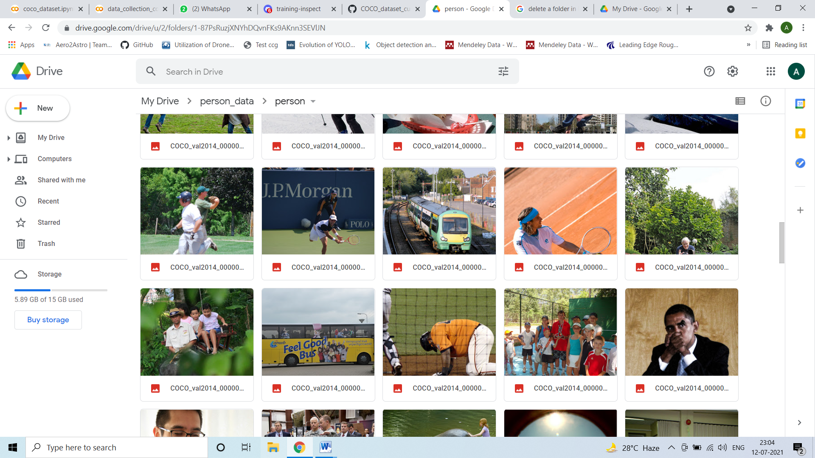

Images link –

<https://drive.google.com/drive/folders/1-87PsRuzjXNYhDQvnFKs9AKnn3SEVlJN?usp=sharing>